**The Milestone Special School – Increasing physical activity**

**THE SOLUTION:**

To train the School’s Peer Mentors to provide lunchtime physical activities for KS2 pupils**.**

**THE ISSUE:** The OPS indicated that 76.9% of our pupils who responded to the survey NEVER took part in organised lunchtime physical activity. This compared poorly with results of the previous survey. A questionnaire sent to all KS2 classes confirmed that no pupils were accessing organised physical lunchtime activities.

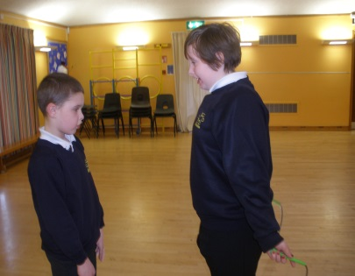

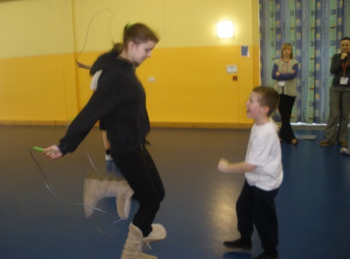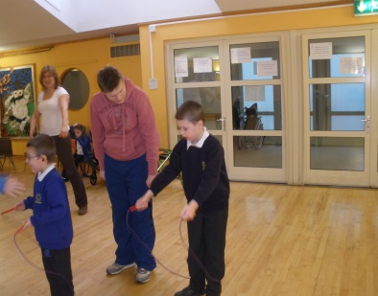

**Evaluation**: Using the Peer Mentors enabled us to offer organised physical activity to a greater number of pupils. There were also considerable benefits to the mentors themselves in terms of raising self esteem and confidence. We hope to offer a wider range of activities in the future to ensure that the number of pupils choosing to take part continues to increase.

**Method:** We identified and trained a group of Peer Mentors, selected from KS3/4. Skipping training was delivered to this group in January 2010. Training included a range of basic skills, games and ways to include non ambulant as well as ambulant pupils. The Mentors responded very positively and began by delivering their own skipping workshops to younger (KS2) pupils. These were a great success and showed very early in the process that our Mentors were able to lead and provide support for younger pupils to access physical activity.

**Results:** A pilot lunchtime skipping club was set up with the aim of engaging 35 KS2 pupils. It was accessed by 27 pupils of all abilities, a significant increase.

